

Practices for Secure Software Report

Table of Contents
Document Revision History 3
Client 3
Instructions 3
Developer 4
1. Algorithm Cipher 4
2. Certificate Generation 4
3. Deploy Cipher 4
4. Secure Communications 4
5. Secondary Testing 4
6. Functional Testing 4
7. Summary 4
8. Industry Standard Best Practices 4

Document Revision History

Version | Date | Author | Comments
1.0 | 10/20/2024 | Taylor McDuffie

Client



Instructions

Submit this completed practices for secure software report. Replace the bracketed text with the relevant information. You must document your process for writing secure communications and refactoring code that complies with software security testing protocols.

- Respond to the steps outlined below and include your findings.
- Respond using your own words. You may also choose to include images or supporting materials. If you include them, make certain to insert them in all the relevant locations in the document.
- Refer to the Project Two Guidelines and Rubric for more detailed instructions about each section of the template.

Developer
Taylor McDuffie

Algorithm Cipher

We implemented the SHA-256 cryptographic hash function for checksum verification. This hash function takes an input string and generates a fixed-length 256-bit (32-byte) hash value. This ensures data integrity by providing a unique, irreversible representation of the input data. SHA-256 is widely used in secure applications due to its high collision resistance and security properties.

Certificate Generation
Insert a screenshot below of the CER file.

Deploy Cipher
Insert a screenshot below of the checksum verification.

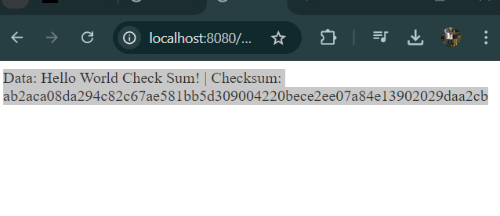

Secure Communications
Insert a screenshot below of the web browser that shows a secure webpage.

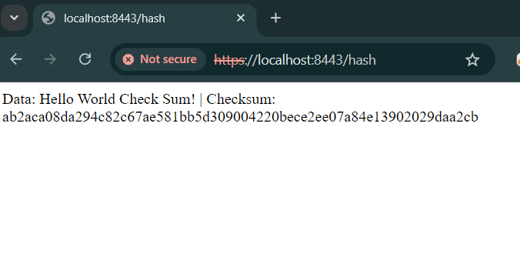

Secondary Testing
Insert screenshots below of the refactored code executed without errors and the dependency-check report.
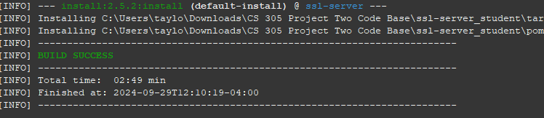
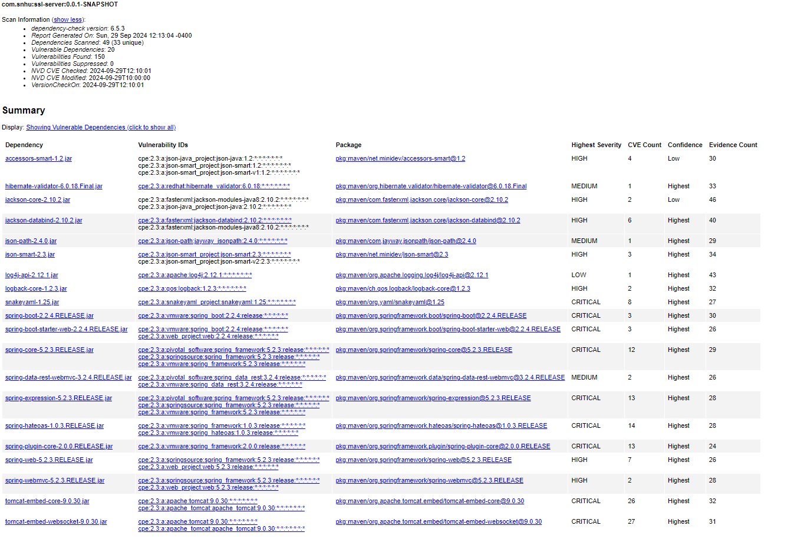

Functional Testing
Insert a screenshot below of the refactored code executed without errors.

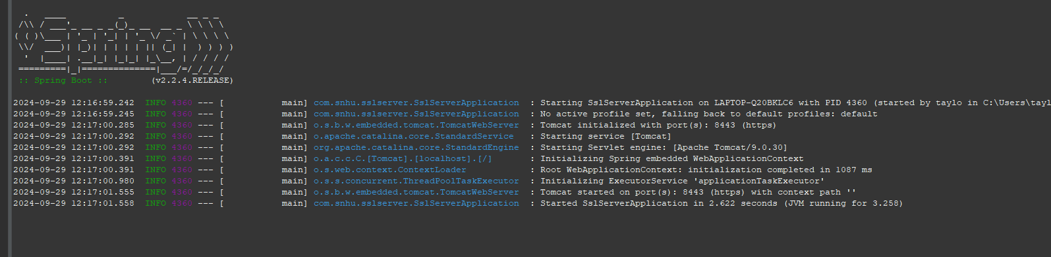

Summary

For this project I refactored the clients code for Artemis Financial to enhance security and make sure that their code is compliant with industry standards. I Implemented the SHA-256 function, I made sure we could use HTTPS, and I conducted static testing.

For the Checksum Verification, the SHA-256 cryptographic hash function was essential for ensuring data integrity. This is achieved using the 256-bit hash value. I exposed the endpoint or the hash that returns a checksum for a static data string.

For the Certificate Generation and Secure Communication, I configured the application to use HTTPS by making a self-signed certificate with the java keytool. This made sure the communication between the client and the server was secure and using SSL and port 8443.
For Secondary and Functional Testing I used static testing with the OWASP Dependency check plugin to make sure there were no new vulnerabilities. Also we did functional testing to make sure the system worked with no errors.

Industry Standard Best Practices

Throughout the project, I adhered to industry standard best practices to make sure the security of Artemis Financials software application was up to date.
1. Encryption and Hashing: The implementation of SHA-256 follows best practices and it is widely adaptable and great for financial institutions.

2. Secure Communication Protocols: I made sure the application could use HTTPS and ensured the data transmissions were encrypted. This mitigates critical concerns for financial companies.
3. Certificate Management: I ensured that communications between the server and clients are authenticated and encrypted by generating a self-signed certificate. This adds additional security.
4. Dependency Checking: The use of the OWASP Dependency-Check plugin made sure I followed best practices for software security by identifying any known vulnerabilities in third-party libraries and ensuring that no unpatched issues are present.
5. Code Refactoring and Testing: Refactoring the code to remove potential security vulnerabilities was done in conjunction with comprehensive testing. This ensured that the application remained secure while preserving functionality.

